Lab 1: Power Management
ESE350: Embedded Systems & Microcontroller Laboratory
University of Pennsylvania
In this document, you’ll fill out your responses to the questions listed in the Lab 1 Manual. Please fill out your name and link your Github repository below to begin. Be sure that your code on the repo is up-to-date before submission!

Student Name:Runzhi Zhou
Pennkey:zrz
GitHub Repository: https://github.com/Lawrencez99/lab1_zrz.git

- According to the Kirchhoff’s current law, I = I_{R1} = I_{R2}.
By Kirchhoff’s second law (KVL),
V₁ = V_{R1} + V_{R2} = R1 * I_{R1} + R2 * I_{R2} = R₁ * I + R₂ * I = (R₁ + R₂) * I
=> I = V₁ / (R₁ + R₂)
=> V_{NODE1} = V₂ = R₂ * I = V₁ * R₂ / (R₁ + R₂) = 5 * 100 / (100+100) = 2.5V
- If R₂ was 850 ohm, V_{NODE1} = V₁ * R₂ / (R₁ + R₂) = 5 * 850 / (100+850) = 4.47V

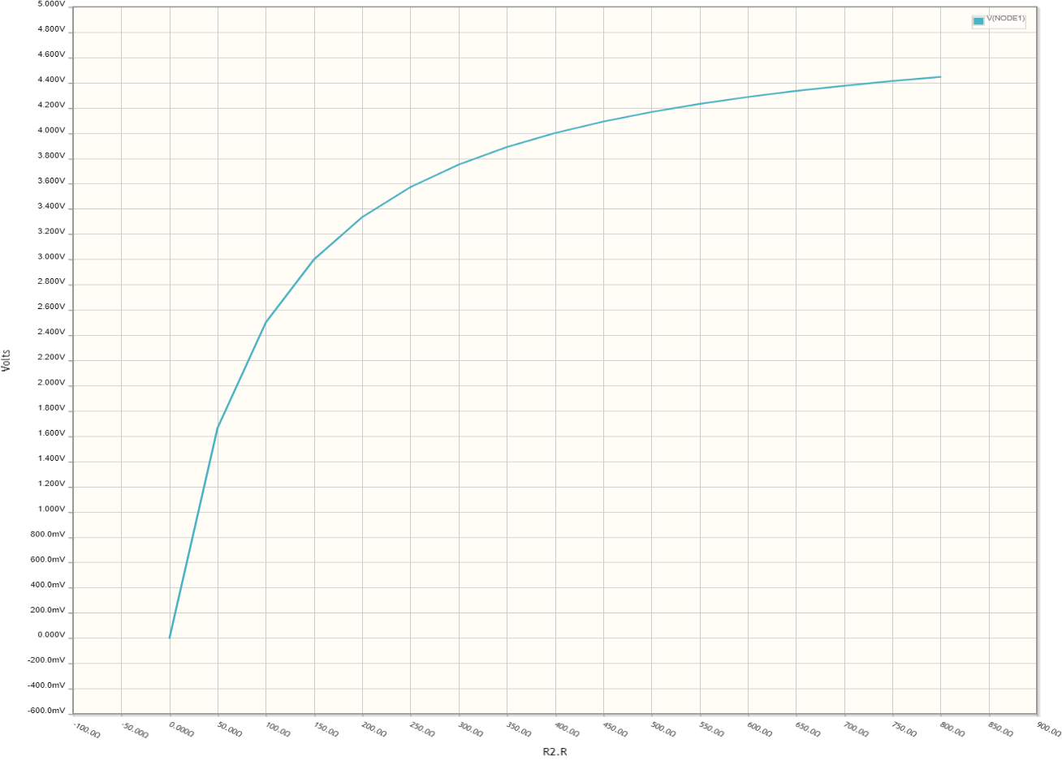
The image is as expected according to the equation we derived from question 1. As R₂ getting larger, more voltage will be occupied by R₂ as the currents through the circuit are the same.
- Scenario1: a voltage divider can be used to measure the resistance of a sensor. A voltage divider is created by adding a resistor in series with the sensor, then we can calculate the resistance of the sensor.
Scenario2: a voltage divider can be used as a level shifter, especially when the load is small. A Voltage divider for example can level the voltage down from a microcontroller with 5 v output to prevent damage to a 3v sensor connected to it.
Scenario3: A voltage divider can be used as a potentiometer, so that we can have a variable voltage from a fixed voltage source.
- The duty cycle setting for the CLK1 part represent the high time of the pulse. The MOSFET become active when the pulse is low, as it is a p channel MOSFET.
- Assume Vout is 3.3V, Vout = Vin/(1-D) => 5 = 3.3/(1-D) => D = 0.34
Assume Vout is 2V, D = 0.6
So in order for Vout to be 3.3V, duty cycle of 0.34 should be selected and for Vout to be 2V, duty cycle of 0.6 should be selected. It makes sense, because the duty cycle decided the percentage of time per period the inductor will store energy from the source voltage, and thus decide the output voltage. But since the efficiency is not 100%, the duty cycle should be a little bit smaller than the value listed above.

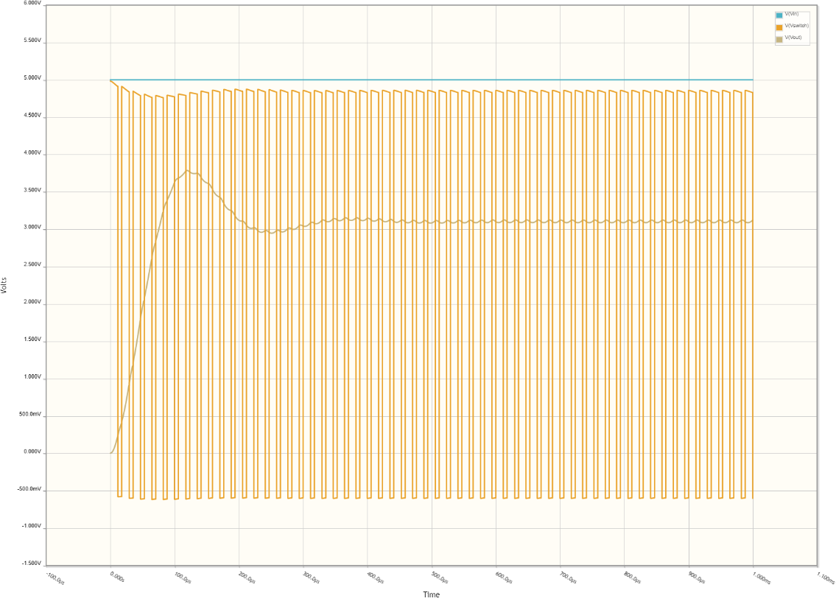
- The dip at around 100us is because of the volt-second balance rule, that the average voltage across the inductor must be zero. The output voltage is steady state output instead of a straight horizontal line is because the inductor keeps charging and discharging as MOSFET goes on and off and the capacitor helps stabilize the voltage.

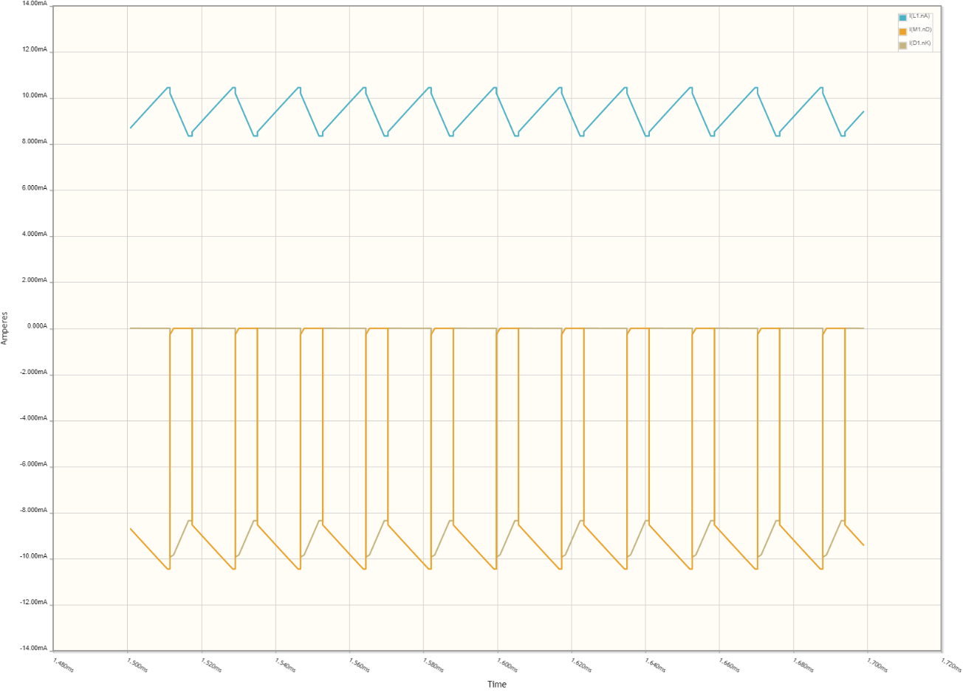
- According to KCL, the sum of the three currents is zero. This is as expected. As the MOSFET is ON, the inductor will charge up and current will increase. The diode will prevent the current flow from cathode to anode, so there will be zero current. the current flow out of the drain will equals to the current flow into the inductor. When the MOSFET is OFF, there will be no current at the drain. The inductor will discharge, and current will drop. The current flow out of cathode of diode will equal to the current flow into the inductor.

Jack | USB | Power Source? | NODE1 | NODE2 | NODE3
0V | 5V
10V | 0V
10V | 5V
3V | 5V

